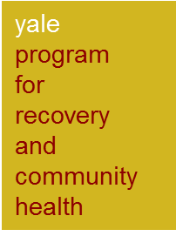  LET(s)Lead ACADEMY  11 February 2022 – November 2022  On-line Training and monthly phone mentoring sessions  Training Application Form | 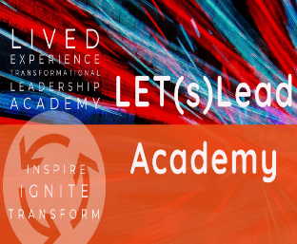

Contact Information
Name
Street Address
City, State, Postcode
Phone
E-Mail Address

Participant Requirements
I self-identify as a person with lived experience of mental health distress and recovery
I can attend a 2-hour online class once each week for 10 weeks (11 February – 29 April 2022)
I will devote at least 4 hours of reading and related commitments between classes
I will attend monthly mentoring sessions 1 time per month for 4-6 months after the 10-week online portion of the training.
I have access to a computer, reliable internet access, and equipment as described below

Required basic computer specifications:

The training will likely use Zoom for videoconferencing.
You need access to a computer - basic requirements include:
- Processor - 1GB of RAM; 2GHz processor
- A high-speed internet connection
  - The use of public access computers and internet (for example, at restaurants and public institutions such as libraries) may result in slowness or errors (timeouts or access problems) when accessing the classroom and course materials. Public access computers may not permit any access to certain course materials or systems due to security limitations.
- Monitor with greater resolution, Keyboard and Mouse is recommended
- Speakers/Headphones and Microphone
  - A noise-cancelling headset is recommended (but not required)
- A web camera capable of video web conferencing
  - Public access computers may not permit usage of web cameras.

Why are you a(n) (emerging) leader and, how might you benefit from participating?
In 500 words or less, please address each question in this section:
1) Why do you consider yourself a (emerging) leader?
2) How might participating in the Academy further your vision/goal(s)?, and,
3) How do these relate to your personal experience of the mental health system and your cultural identity(s)?

Transformational Change Project
In 500 words or less, please tell us about your passion and vision, for transformational change (interests, issues or causes). Please describe the areas you would focus on during your time with the LET(s) Lead Academy?

Previous Leadership Experience
In 250 words or less, please tell us what experience you have in community leadership (social change or other initiatives). Have you built support for a cause of any kind (small or big)? What was the experience like? (Did you work alone or with others or a group (formal or informal). Have you taken any steps towards developing a new concept or idea that you are passionate about? If so, please describe. If not, what do you think would be needed to get you to that next step?

Diversity, equity and inclusion
In 250 words or less, please tell us about your background, perspectives and experiences Can you tell us how you position yourself in this context?

Connection to your community
In 500 words or less, please explain how you serve your community. We will be guiding you in completing a project to serve the mental health needs of your chosen community.

Optional Information

Please check the boxes below as applicable.
Optional demographics (please check all that apply):

___ Aboriginal and/or Torres Strait Islander
___ Culturally and Linguistically Diverse background
___ Alcohol and other drugs/ co-occurring

Please also check if you identify with one or more of the demographics below:

___ Young Adult ___Veteran ___LGBTQI ____Rural, Remote

___ Other than listed (please specify)

By submitting this application, I affirm that the facts set forth in it are true and complete. I understand that if I am accepted as a participant, I am making a commitment to full participation and attendance for all the requirements of the training.

Agreement and Signature
Name (printed)
Signature
Date

Application Deadline: 30 December 2021 9.00pm AEDT

Applications are to be submitted to: nmhccf@mhaustralia.org

